Dark Sphere May 2024 Kill Team Tournament
When: May 11th and 12th 2024
Where: Dark Sphere Sheppard’s Bush Megastore
Players: 64
Rounds: 6

Tournament Format
Kill Team Selection
Rosters of up to 20 operatives will be used for the event as per normal (with 30 for Inquisitorial Agents). Rosters must be submitted to BCP no later than 23:59 on Friday the 3rd of May. This is so that the organisers have time to review all rosters and factions to ensure they are legal. Failure to do so on time without a valid reason will result in a -2 VP penalty for each game.
We will be using the Battle Ready points scoring for each game (and thus you will not receive these points each game if you fail to submit your roster on time). All models in your roster must be painted and based. To count as Battle Ready you should meet the minimum standard as pictured below:
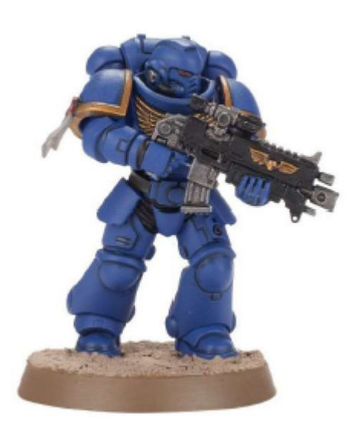
Proxies and Conversions
Please contact the TO in advance for any conversions/appropriate proxies you plan to use for the event. All models should be clear to the opponent of a similar size to the base model. Remember, the event will be playing as modelling for disadvantage, so making models smaller than before etc will lead to slight penalties.

Rules, FAQs and Erratas
The tournament will use all Games Workshop rules publications, FAQs, and errata published up to and including 3rd of May 2024. Anything published after this date will not be used (subject to TO discretion). We will also be using our own event FAQ to cover any grey areas not detailed in Games Workshop publications.

Rules Queries
If you have any queries relating to event rulings, please submit them to the Can You Roll a Crit Discord or Facebook page.

What You Need to Bring
1. Your Kill Team.
2. The rules for anything you're using - paper or electronic is fine, but these should be available to your opponent to check if necessary.
3. Dice, measuring tapes, markers, and other paraphernalia
4. Chess Clock (Optional)

Time Milestones
2:00 remaining – Start round (formally)
1:50 remaining – Complete pre-game mission sequence and begin Turning Point 1
1:20 remaining – Turning Point 1 complete, begin Turning Point 2
0:50 remaining – Turning Point 2 complete, begin Turning Point 3
0:25 remaining – Turning Point 3 complete, begin Turning Point 4

Chess Clocks
If both players want to use a chess clock in a game, a chess clock should be used. During rounds, there will be regular announcements of the amount of time that has elapsed. If you are concerned about time management in a game, please let a judge know as soon as possible.
Chess clocks cannot be implemented mid-game.
For rounds 4, 5 and 6, undefeated players (i.e. games with 2 undefeated players each) only need a single player to request the use of a chess clock for it to be used instead of the prior requirement of both players needing to consent.
Once a player runs out of time on their clock they can make no further actions except to make saves and score points that require no further interaction e.g. if your operative is controlling an objective when the time runs out, you will be able to score points for that objective as long as you can do so without moving the operative. If both players run out of time, the game ends. If this happens before the game has concluded, players should score any further points remaining as described above.
In general, each player is responsible for their own time on the clock, but we expect players to act sportingly with regards to clock management. The goal of the clock is to ensure both players get to participate fairly in the game, not to create an angle to exploit.
Judges may allow single opponents to allow the use of Chess Clocks against opponents who have consistently not finished games on time (e.g. 2 or more games in a row). This will only be done on a case by case basis in exceptional circumstances.

Chess Clock Settings
- 55 minutes for each player on the clock
- 10 minutes of paused time (off clock) for all simultaneous events (all time before barricade placement)
- Totals at 110 minutes for the clock, 10 minutes for off clock
- Ruilings/Judge calls either happen on the challenging player’s time or paused time (if judge decides to pause the clock)
- Clock can never be paused except at the end of each turning point for determining victory points, flipping orders and determining initiative

Missions and Scoring
Missions will be determined randomly each day using the Approved Ops missions (Loot, Secure and Capture).

Saturday
10:00 to 10:20 – Registration
10:20 to 10:30 – Event Briefing
10:30 to 12:30 – Round 1
12:30 to 13:30 – Lunch
13:30 to 15:30 – Round 2
15:30 to 16:00 – Break
16:00 to 18:00 – Round 3

Sunday
10:15 to 12:15 – Round 4
12:15 to 13:00 – Lunch
13:00 to 15:00 – Round 5
15:00 to 15:30 – Break
15:30 to 17:30 – Round 6
17:45 to 18:00 – Awards Ceremony and Event End

Your opponent in round 1 will be at random. Subsequent rounds will be paired via random Swiss within your bracket (e.g. people on 2-0 will be randomly paired with other players on 2-0 etc). Final standings will be determined by Tournament Points, Opponent Win Percentage, Total Victory Points, then total Tac Ops.

Final standings will be submitted to the ITC.

Terrain
There will be 32 tables of terrain. 16 of these will be the asymmetrical Into the Dark layouts from LVO 2024 by Squad Games. The other 16 tables will be the Approved Ops maps for Bheta-Decima using the Can You Roll a Crit? scatter terrain pack, note that Map layouts 5 and 6 will not be used.
Photography
The Dark Sphere team will be taking photos throughout the event.

Prizes
Prizes will be awarded in the following categories:
Best General – 1st, 2nd, 3rd
Best in Faction – Space Marines, Imperium, Chaos, Aeldari, Other Xenos, and Best Compendium
Best Kill Team – One prize each for Judges’ Choice (1st, 2nd, and 3rd) and Voters’ Choice Single Kill Team painting contest.
Most Sporting Player – As voted by players
We have prizes for every category and a selection of fantastic as well which will be announced closer to the event date!

